# Display Advertising

**Background**

# Background

Display Advertising revenues roll up to the Marketing Services and Other (MS&O) line item on our external financial statements. Similar to Core Transaction Revenue, Display Advertising revenue is managed regionally and is split into regions: NA, UK, DE, International (CA, AU, FRIT, Sited) and iCBT & Others. Local teams manage ad inventory and pricing per the traffic and demand for their respective sites.

**Process**

# Overview

Display advertising are ads displayed on various eBay site pages, including the home page, search results page (SRP), view item page (VIP), etc. These ads are commonly referred to as banner ads.

see an example of a homepage event featuring a medium rectangle and a super leader:

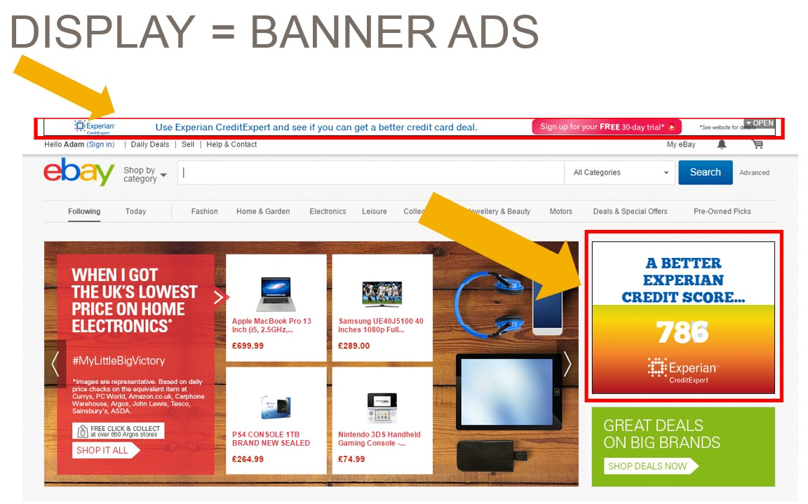

On eBay Display Advertising, in this document includes the UK, DE and FRIT eBay sites.

## Pricing/Monetization

Advertising contracts are monetized in several ways. The four primary monetization types are:

|  |  |
| --- | --- |
| **Type** | **Description** |
| **CPM** | Cost per thousand impressions. We charge the advertiser for each impression we deliver. |
| **CPC** | Cost per click.  Impression volumes may vary to generate actual clicks on the ad leading to the advertiser’s hosted content. Advertisers don’t pay by the impression but by the click. |
| **Fixed Price** | Typically used for event based advertising, such as a home page event in which we display the ad on the home page for all traffic for a specific period of time. The advertiser pays a fixed price regardless of the actual impressions/clicks served. |
| **CPO/CPA** | Cost per Order/Cost per Acquisition.  Advertisers only pay when a user not only clicks on an ad, but then performs some action on the advertiser’s hosted page.  For example, signing up for a credit card or a free insurance quote, etc.  Typically, we must rely on reporting from the advertiser to validate the amount of revenue earned under these contracts. |

## Hive (Hive.My.Salesforce.com)

The primary system used as a tool for managing, tracking and delivery of advertising services by the EU Marketplaces Advertising team is Hive, a web-based CRM tool.

* eBay Marketplace sites/platforms utilize what is referred to as the [**EU Advertising Hive instance**](https://hive.lightning.force.com/lightning/page/home).
* In addition to being a CRM tool it has been configured with additional features such as a workflow for contract initiation and approval, contract repository, and the reporting “source of truth” for revenue recognition purposes.

# Standard vs. Non-Standard

From a controlling perspective all contracts can be split into two categories, Standard, and Non-standard. The type of contract has key implications on the downstream process for contract approval, signature, accounting and invoicing. Regardless of the contract type, all contracts are entered into Hive to maintain a single source of truth for all EU Display Advertising.

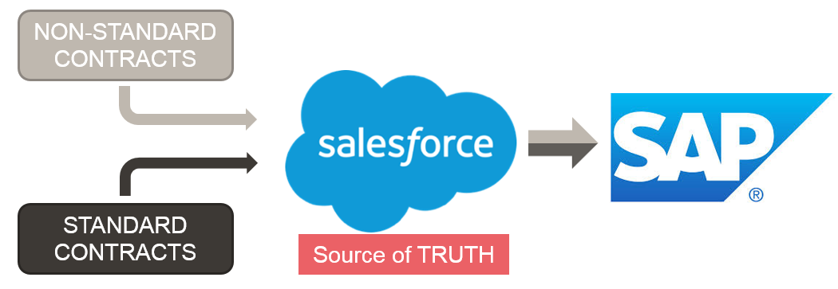

## Standard Contracts

### Types of Standard Contracts (Products)

The tabs below describe the various typical standard contract types. Each of the products below are mapped to their respective SAP product line here: SAP GL & Product Line Mapping.

**Ad Sales**

Direct deals negotiated between eBay advertising team and advertisers (**3P = Third Party Advertising**). Typically simple deals: CPM (Cost per Mil i.e. cost per thousand views) or CPC (cost per Click) deals. There are not only direct deals between eBay advertising sales team and advertisers but also between eBay and the various media agencies acting on behalf of advertisers.  Ad placements are served via the AdServer (DFP) with automated delivery data pushed to Hive.

In some cases, we may sign annual volume discount agreements with agencies (Yearly Discount Agreements), the individual opportunities roll up in product line AdSales, despite there being a MSA level agreement with an agency network.

For DE, 3P Advertising has been stopped end of July 2023. There are only a few deals running which are not cannibalizing eBay.de webpage (e. g. Mastercard, Visa).

**Ad Networks**

Bulk or wholesale ad sales. eBay sells large volumes of lower value ad impressions to Ad networks for a fixed floor CPM or a revenue share if they manage to sell the inventory to their customers for more than the floor CPM.

**Multinational**

eBay sells advertising space to advertisers who wish to advertise in multiple markets (countries).  In terms of set-up/delivery there is no significant difference to a normal Ad Sales, however, currently these types of deals require a bit more set-up coordination and are managed primarily out of the UK.  Therefore, a separate product line used to track these revenues.

**First Party (1P)**

Refers to display advertising with the unique feature that when a user clicks on the display ad banner it directs traffic internally on the site, keeping the traffic on eBay. 1P is sold to eBay registered sellers who want to direct traffic to their stores or listings, or Brands that want to promote hosted events on the site or that may have certified re-sellers on the site.  1P is split into two products, Merchant Promotions and Brand Solutions. Merchant Promotions is any internally linking ad sold to a merchant who sells directly on the eBay platform. Brand Solutions is any internally linking ad sold to a customer that does not sell directly on the site.   Advertising that is internally linking has separate accounting treatment depending on the sales channel (direct vs agency) see 1P accounting page for more detail here **First Party (1P) Advertising**.

### New Contract Creation

The account manager creates a new Opportunity (also referred to as Insertion Order or IO) in Hive including all campaign and financial information.  Upon creation Hive will generate a unique opportunity number (e.g. ON-99999).  Once all relevant data has been entered the account manager can submit for approval. The Hive workflow will automatically place the request in an approval flow.  Depending on the value of the IO, Hive will automatically notify the appropriate BU, Controlling and APG approver as necessary.  Please see the detailed Hive approval flow here **Hive Approval Flow**. Approval is documented within the opportunity. Hive has the pre-approved IO template with standard T&C's embedded within. The system is able to take the variables of quantity, product, and price entered by the account manager and generate a contract. Once all approvals have been obtained, the sales team can generate the quote from Hive to be sent to the customer for signature.

See example standard IO below

Once the business has obtained the signed IO and updated the campaign status to “booked”, the campaign data can be pushed to the ad server (DFP) for delivery (some campaigns may require further customization by the Ad Ops team sitting in Prague).  It is the responsibility of the business to ensure that the signed IO/contract is attached to Hive for support.  In the eBay Hive instance the business is unable to set the campaign status to “booked” without selecting a field that confirms the signed agreement has been received.  Please see the application controls section in the “Access Management and Security over SFDC for eBay” SOX narrative.  All reports used for invoicing and revenue accruals include a filter to exclude opportunities that do not have the stage set to “booked.”

DFP will update Hive on the impressions/clicks delivered daily via an automated API.  Hive will calculate the revenue as per the IO specifications (price, quantity delivered etc.) based on impressions and “cost-per-mil” (CPM) rate (cost per thousand impressions) or “cost-per-click” (CPC) or fix price placements (e.g. Homepage events).

### Customer Creation

If the planned campaign is with a new customer, the account manager first must create a new account within Hive. They are required to fill out key information such as account type, billing address, VAT ID, etc.  Once created in Hive, the account manager can select a button “Request SAP ID”. This will generate an email request to the eBay Global Billing & Payments team.  All invoicing is performed using the SAP SD (Sales and Distribution) module.  GB&P creates the customer in SAP generating the specific SAP ID and will then update the Hive account page with the SAP ID. For more information on Customer Master data maintenance see [**here**](https://wiki.vip.corp.ebay.com/display/GBAP/Maintaining+INTL+Customer+Master+Data).

### Amendments

**Amendments Required When . . .**

An amendment to a standard IO is required in the following scenarios:

* Change in the price or products in the contract even without revenue impact
* Any change that results in a change in the total value of the order
* Any change to the financial or legal terms & conditions (this scenario should kick-off non-standard approval process)

**NO Amendment Required When . . .**

An amendment to a standard IO is **NOT** required in the following scenarios:

* Shifts in quantities, not impacting the total value (Revenue optimization – email notification is sufficient)
* Corrections for under-delivered or wrongly delivered campaigns approved by the Business

### Advertising Delivery

Typically, advertisers book specific volumes of impressions to be delivered in a specific period. For CPM/CPC per our contract terms, we do not promise or guarantee delivery in a specific period as we cannot fully predict future traffic activity.  As such, campaigns are set up to “over-deliver” the quantity ordered by a slight amount to ensure we meet the order quantity. However, in this scenario we only charge the customer for the quantity ordered. In a scenario where a campaign is under-delivered, we will only charge for the impressions actually delivered.

## Non-Standard Contracts

### Types of Non-Standard Contracts (Products)

By definition, a non-standard contract is any contract for which the standard template is not sufficient. Any deviation of the terms from the pre-approved template is considered “non-standard.” Although non-standard contracts could have infinite variety, there are several recurring types classified below. Each of the products below are mapped to their respective SAP product line here SAP GL & Product Line Mapping.

**Partnership**

Direct Ad deals including more components/deliverables than an typical Ad Sales deal such as: micro sites, newsletters, or contracts with CPO/CPA components revenue models.  Usually the advertiser has a separate existing relationship to eBay. Primarily used in DE. Examples include Deutsche Post and Hermes partnerships.

**Programmatic**

Ad sales through various 3rd Parties, referred to commonly as “Sell Side Providers” or SSPs, that provide platforms or marketplaces through which advertising agencies and standalone customers can bid and purchase advertising on eBay in a dynamic auction environment (often referred to as real time bidding [RTB], or Open Marketplace [OMP]).  In addition to OMP services, SSP’s also provide Private Marketplace deals (PMP), through which publishers can offer a specific deal to a specific buyer that is facilitated by the SSP.  The sales team determines what inventory is available to the provider as well as price floors for bidding.  Due to automated nature of the contracting process, this has quickly become the channel of choice for most advertisers and publishers.  Approximately 80% of eBay Advertising revenue is sold through SSPs. For more information on how programmatic advertising works, see here (content to be created).

### New Contract Creation

For non-standard contracts, for which Hive standard templates cannot be used, the business must submit a Contract Request Form (CRF) to Legal. The local advertising team negotiates with the customer and works with Media Planning if the contract includes media impressions.  The respective group completes and submits a CRF into the Legal Database. A contract is drafted by Legal based on discussions with the local advertising team the EU Controlling team regarding the customer’s requests and the potential revenue recognition impact of the contract

Legal finalizes draft of contract and provides contract approval for all non-standard deals. Depending on the legal entity, new contracts are tracked through CMS (Contract Management System) which provides a workflow for contracts and supports electronic approval and signatures of contracts. All contracts tracked through CMS also need a Contract Approval Sheet (CAS) which summarizes the contract and outlines which approvals and signatures are required. This system is supported by the contracts administration team sitting in Bern, Switzerland.  The following legal entities (with respect to MS&O revenue) are supported by CMS and the applicable signature process:

* + 0111 -  eBay Marketplaces GmbH (AU, APAC, Non-EU and Non-UK revenue)
  + 0075 – eBay (UK) Ltd (UK revenue)
  + 0062 - eBay GmbH (DE and EU revenue)

For entities not supported by CMS, the local Advertising Group obtains signatures in accordance with the signature policy set forth by the local Legal department.

* Details regarding the contracting process can be found at the legal hub here: [**Legal Hub**](http://lob.corp.ebay.com/sites/legal/MarketplacesEU/Pages/ContractProcess.aspx)
* Details regarding the CAS can be found here: [**CAS**](http://lob.corp.ebay.com/sites/legal/MarketplacesEU/Pages/Signature-Process-for-entities-handled-by-Bern-Contract-Administration.aspx)
* All non-standard revenue contracts valued above $250,000 require Controlling approval. If the contract is valued in a non-USD currency, the annual plan rate should be used for conversion into USD. Annual plan rates can be found here:[**FX Annual Plan Rates**](https://ebayinc.sharepoint.com/sites/TW32967-MPFinanceSystems/Pages/FX-Rates.aspx)

If a contract is valued above $2M, or it contains unusual/complex terms, the Accounting Policy Group (APG) is required to approve. Please see the APG policy here: [**APG Policy**](https://hub.corp.ebay.com/site/cao-accountingpolicy/page/home)

Once the contract is fully approved and signed by the customer, similar to the standard process, the account manager must create a new opportunity in Hive including all campaign and financial information.  The Hive workflow will automatically place the request in an approval flow based on the value. This is technically redundant, as off-line approval has already been provided, but it ensures documentation is retained in Hive our main repository and source of truth. Please see the detailed Hive approval flow here**Hive Approval Flow****.**

### Customer Creation

The customer creation process for Non-Standard contracts is the same as standard contracts mentioned here

### Amendments

Any change to the terms and conditions not explicitly allowed in the contract itself requires a contract amendment.

### Advertising Delivery

Delivery for most non-standard deals cannot be easily tracked in Hive due to complexities of the campaign itself, complexities of pricing (e.g. volume based discounts or revenue share commission, etc.), or the source of delivery is something other than our ad server, DFP. In such cases we must rely on the contracting party to provide revenue earnings reporting.  The account managers must then update Hive manually with the revenue earned and attach the relevant 3rd Party supporting documentation.

The next steps in the advertising process can be found here → Revenue Recognition and ME Close

**Table of Contents**

* Background
* Overview
  + Pricing/Monetization
  + [Hive (Hive.My.Salesforce.com)](#DisplayAdvertising-Hive(Hive.My.Salesfo)
* Standard vs. Non-Standard
  + Standard Contracts
    - Types of Standard Contracts (Products)
    - New Contract Creation
    - Customer Creation
    - Amendments
    - Advertising Delivery
  + Non-Standard Contracts
    - Types of Non-Standard Contracts (Products)
    - New Contract Creation
    - Customer Creation
    - Amendments
    - Advertising Delivery

**Resources**

Top of Form

Search

Bottom of Form

Revenue Glossary